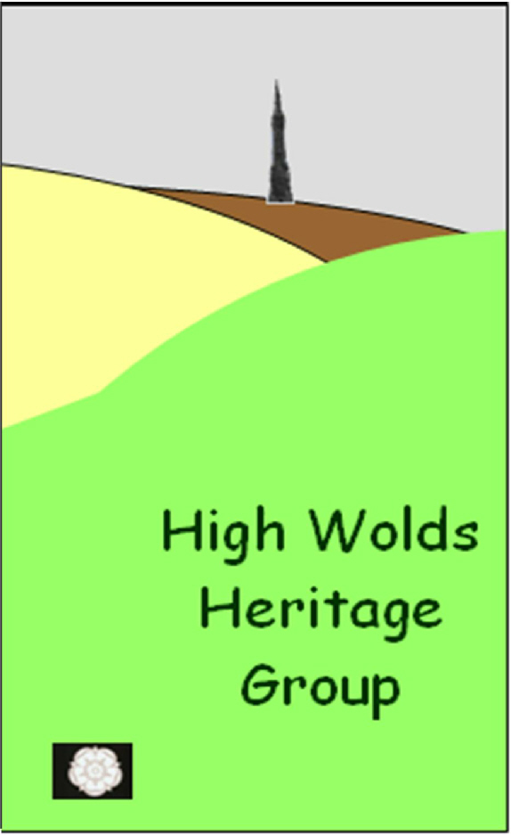
Guided Walk round Wetwang
23rd May 2013

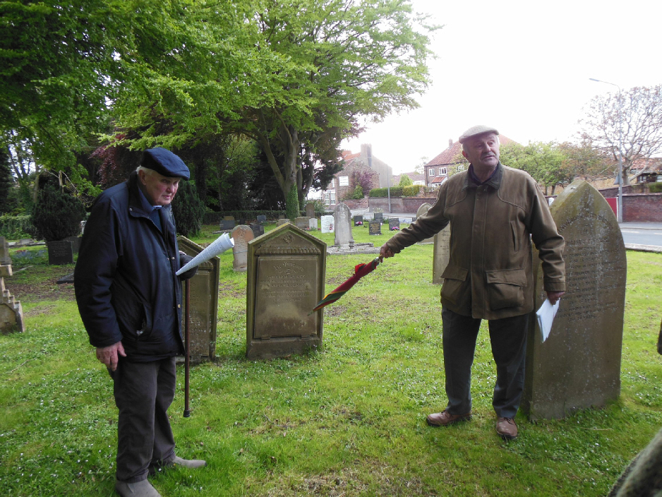

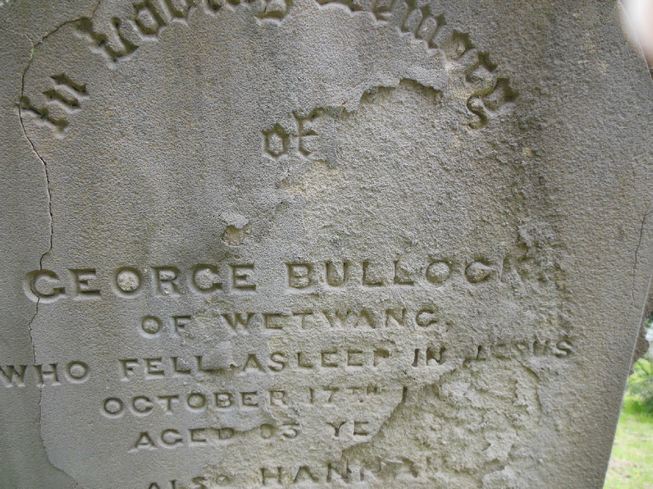

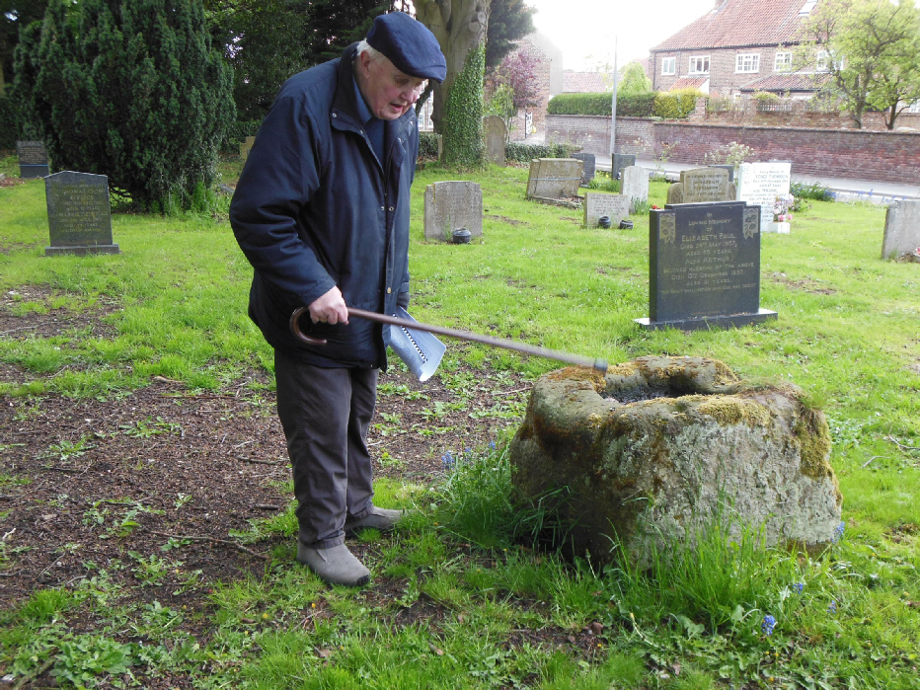
David Lunn and Chris Whitfield began the walk with a tour of the church graveyard.
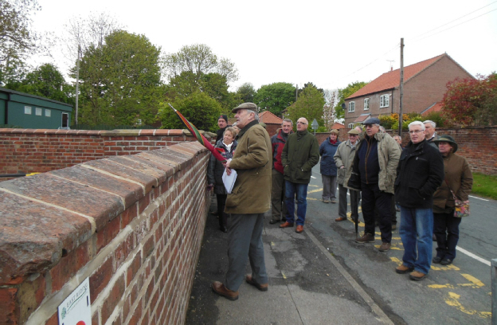

Chris then continued the walk round the village, pointing out the location of chapels and the buildings that had been farmhouses.

There was a good turn-out for the walk, which everyone thoroughly enjoyed – despite the cold rain.
We always now seem to have poor weather for these village walks!
After the walk, several people retired to the warm surroundings of ‘The Victoria’ to enjoy a meal together in a private room.
We presented David Bull with a bottle of Champagne as a “Thank you” for his work on the HWHG committee. He is leaving to move to Scotland where he is to be married on one of the Orkney Islands. We shall miss him and send our best wishes to him and his fiancée.

